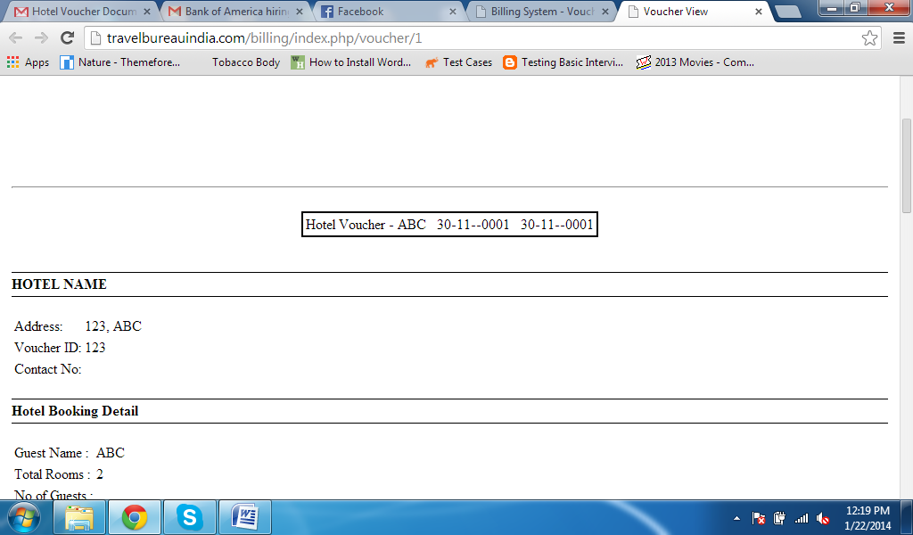

1. Hotel name should be shown in Brackets.
2. In PDF View, The check in date and Check out date should be correct shown.
3. Contact No. should be Display. So that Add a Contact Field In Voucher Document.
4. **Check in Date** Field should be Visible under Hotel Booking Details.

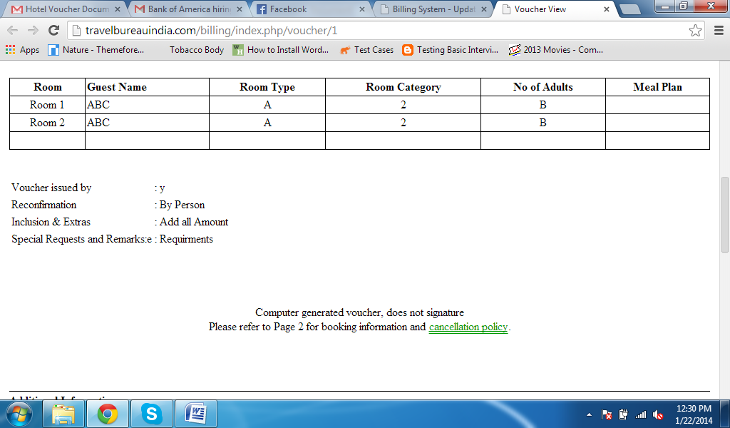

At the time of voucher creation that Meal Plan should be shown under this table.

**Under Inclusion & Extras:**

If We Select EPAI then **Room Only and taxes** is shown

If We Select CPAI then, **Breakfast and taxes** is shown.

If we select MAPAI then, **Breakfast and Lunch / Dinner and taxes** is shown.

If we select APAI the, **All meals and taxes** is shown